# ME2 Computing Coursework summary

## Students: Louis Manestar (01360458) & Alice Norton (01495431)

A) What physics are you trying to model and analyse? (Surely that is crazy!)

We are trying to model the upper E string on a violin, and how this sound propagates through a room. The air is assumed to be still, perturbed only by the violin. The violin string is assumed to be flat and that at , a bow strikes the string at some point, giving it an initial velocity.

B) What PDE are you trying to solve? (write the PDE)

This problem has two PDEs: A 1D hyperbolic PDE for the violin string and a 2D hyperbolic PDE for the surrounding air which carries the sound as compression waves:

C) Boundary value and/or initial values for my specific problem: (be consistent with what you wrote in A)

for a bow striking the string at its centre.

To simulate a violin, the velocity was modelled as a skewed sine wave, with zero velocity at the boundaries and maximum velocity at the bow location, approximately 300mm from the left of the string. The function used for the skewed sine wave is in the code but is too long to write in this summary.

Where describes all the points in the room that are directly next to the string. This is how the soundwave is transferred from the violin to the air. Note here is the x coordinate of the violin relative to the room.

E) I am going to discretise my PDE as the following:

Discretising the time into samples denoted and using the finite difference method, the PDEs become:

The solution to the PDEs at a point where becomes:

D) What numerical method are you going to deploy and why?

Both PDEs will be approximated using an explicit finite difference method. Explicit was chosen as it is simpler to use than implicit, and as long as the system of equations are stable (), the numerical solution will be accurate enough. Finite difference was chosen as it is the only explicit method we have been taught for the wave equation.

Figure

Figure

Figure

Figure

Figure

Figure

E) I am going to discretise my PDE as the following (cont…)

As at , the and values do not exist, the initial velocity is used to approximate the next sample:

Where is defined as:

for the explicit method to be stable.

G) Other remarks (limits of the model, convergence problems, possible alternative approaches, anything you find relevant and important to mention):

Although most of the results from the model were as expected, an area that could be improved is better defining how the string amplitude transfers to a pressure, as the amplitude of the air is meaningless otherwise. This would have been interesting to do, but is too complicated and would only indicate what volume we get from the violin.

F) Plot of results and comments (discuss how the results describe the physics and comment on any discrepancies or unexpected behaviours):

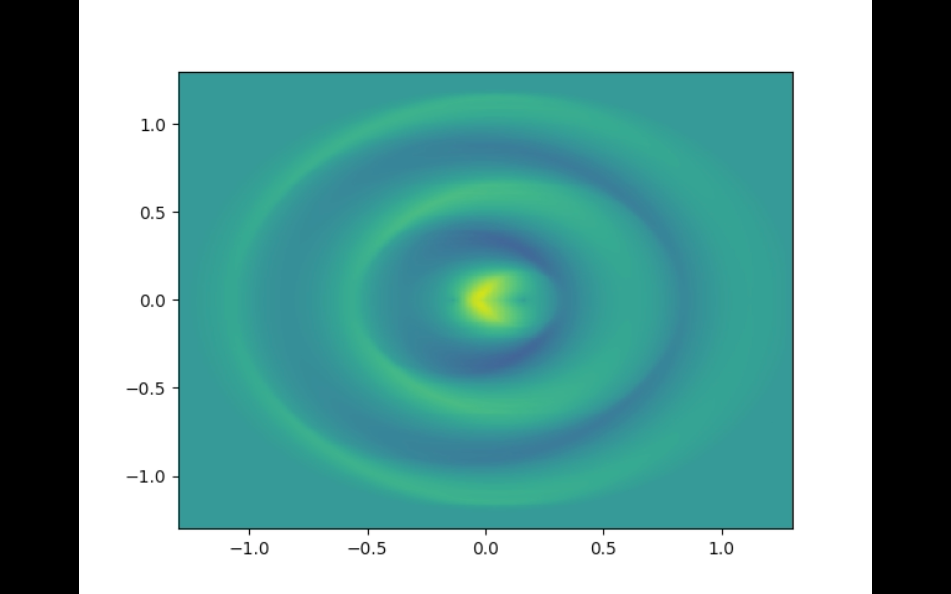

Figures 1 and 2 show the string oscillating as expected (compared to a [violin in slow motion](https://www.youtube.com/watch?v=6JeyiM0YNo4)). When animated, the string stretches a lot more than you would see in an actual violin. This is a flaw in the PDE, as in reality it should include some spring constant opposing extension of the string. It can also be seen in Figure 2, the longer length of the string, which is following the peak, stops being a straight line and starts to curve a little, as if it has become slack. This is likely a fault of the explicit method having too large of a time step or coarse mesh size.

Figures 4-6 show a top view of the sound from the violin propagating away. This again is what we expect to see. In Figures 5 and 6, the rings produced by the peaks and troughs change thickness depending on where they are relative to the string. This is really interesting, because it shows the string creating a kind of doppler effect as its wave propagates faster away/towards the wave that is carrying the previous wave. We wouldn’t expect to see this, because we assumed the string propagation was much faster than that of the air, but it does show up here.

Finally, Figure 3 shows the air amplitude at the point (0, 0.65) on the contour plots (i.e. directly above the string). It shows the air being initially still, taking approximately 2 ms for the first wave to reach it. The amplitude of the wave can be seen to be about a fifth of the original amplitude. This is due to the wave spreading out, therefore decreasing the energy the wave is transmitting at that point. The amplitude increases slightly at 6 ms due to the wave reflecting at the boundary as shown in Figure 6.

From Figure 3, the frequency of oscillation was measured to be approximately 650 Hz. The open E string on a violin oscillates at 659 Hz.